📄 HR Analytics Project
1. Project Overview
This project focuses on analyzing employee data to understand attrition patterns, salary distribution, job roles, and workforce behavior. The objective is to identify key factors affecting employee turnover and support data-driven HR decision-making.

2. Dataset Summary
The dataset includes employee-related attributes such as:
- Department
- Job Role
- Age
- Gender
- Monthly Income
- Work-Life Balance
- Years at Company
- Total Working Years
- OverTime
- Attrition
Data Issues Identified:
- Missing values in some columns
- Inconsistent categorical values
- Need for grouping and feature engineering
- Data required transformation for analysis

3. Data Cleaning & Structuring (Excel)
- Removed duplicate records
- Handled missing values
- Standardized categorical fields
- Structured dataset for analysis
- Prepared clean data for Python, SQL, and dashboard

4. Data Analysis using Python (Google Colab)
Python (Pandas) was used for data exploration and analysis.
- Calculated total employees and attrition count
- Computed attrition rate
- Analyzed department-wise attrition using groupby
- Studied salary impact on attrition (mean income of attrited employees)
- Used crosstab to analyze OverTime vs Attrition
- Performed job role-wise attrition analysis
- Examined work-life balance impact on attrition
- Analyzed age group-wise attrition
- Studied attrition trends based on years at company
👉 This helped identify key patterns affecting employee retention.

5. Data Analysis using SQL
SQL was used to extract structured insights from the dataset.
- Calculated total employees, attrition count, and attrition rate
- Analyzed attrition across departments, job roles, and gender
- Compared salary distribution between attrited and non-attrited employees
- Studied impact of overtime and work-life balance on attrition
- Performed experience-based analysis using years at company
- Identified high-risk employees based on salary, overtime, and satisfaction
- Created a SQL view for Power BI dashboard integration

6. Dashboard (Power BI)
An interactive dashboard was created to visualize key HR insights.
It includes KPI cards such as total employees, attrition count, attrition rate, average salary, age, and experience.
The dashboard also visualizes attrition trends across education field, age groups, salary slabs, job roles, and gender, along with slicers for department, job role, and education field.
👉 This helps HR teams quickly identify attrition patterns and workforce trends.

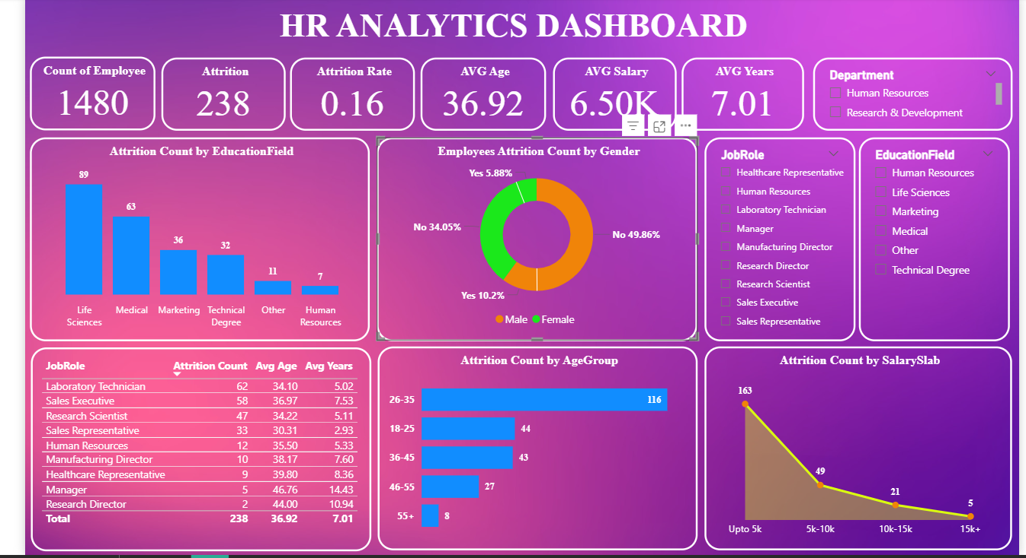

7. Key Insights
- Attrition is higher in younger age groups (26–35)
- Low salary employees show higher attrition rates
- Certain job roles like Lab Technician and Sales Executive have higher turnover
- OverTime increases likelihood of employee attrition
- Work-life balance and salary are major influencing factors

8. Real-World Applications
- Helps HR teams reduce employee attrition
- Supports workforce planning and retention strategies
- Identifies high-risk employee groups
- Improves hiring and compensation decisions
- Enables data-driven HR management

9. Conclusion
This HR Analytics project demonstrates how Excel, Python, SQL, and Power BI can be used together to analyze employee data and extract meaningful insights. It helps identify attrition drivers and supports better HR decision-making.

